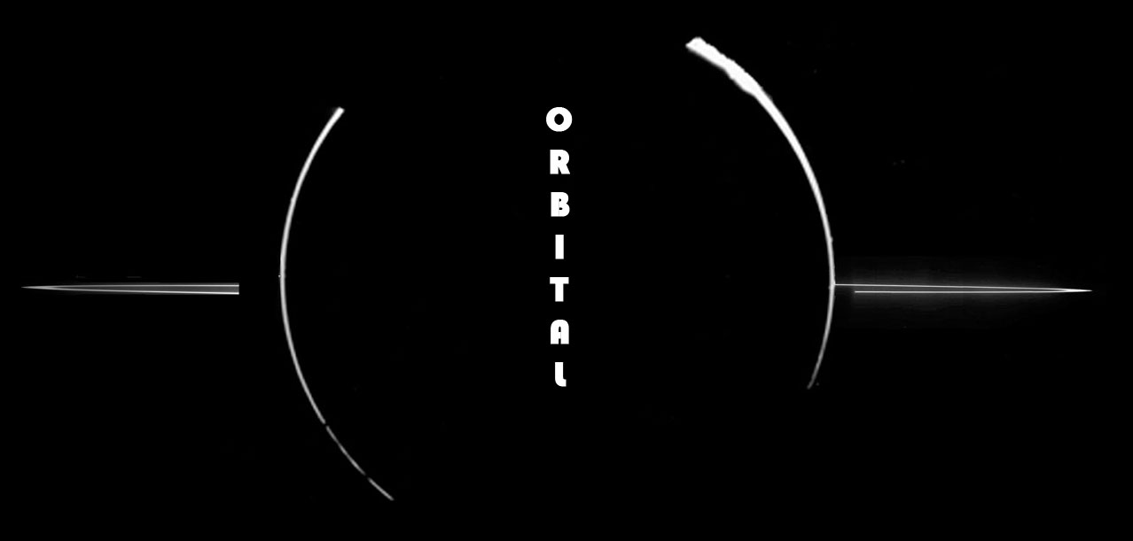

Game Design Document
By
James Stewart
TABLE OF CONTENTS

Section 1: Game Design . . . . . . 4
1.1 High Concept . . . . . . . . 5
1.2 Story . . . . . . . . . . 5
1.3 Style and Aesthetics . . . . . . . 5
1.4 Gameplay Mechanics Overview . . . . . 6
1.5 Orbital Physics . . . . . . . . 7
1.6 Obstacles . . . . . . . . . 9
1.7 Game Flow . . . . . . . . . 10
1.8 Level Progression and Structure . . . . 10
1.9 Winning the Game . . . . . . . 12
1.10 Player’s Avatar: The Arc . . . . . . 12
1.10.1 Shields . . . . . . . . . 13
1.10.2 Tangent Time . . . . . . . . 13

Section 2: Game World . . . . . .14
2.1 Game World Overview . . . . . . . 15
2.2 Parallax-Scrolling Background . . . . . 15
2.3 Special Planets . . . . . . . . 15
2.4 Obstacle Representations . . . . . . 18

Section 3: Game Textures and Backgrounds .21
3.1 Image Sources . . . . . . . . 22
3.2 Image Formats . . . . . . . . 22
3.3 Image Catalogue . . . . . . . . 22
3.3.1 Animated Art Assets . . . . . . 23
3.3.2 Environmental Art Assets . . . . . 24
3.3.3 Planet Art Assets . . . . . . . 25
3.3.4 The Arc . . . . . . . . . 28

Section 4: User Interface . . . . .30
4.1 Game Control Overview . . . . . . 31
4.2 Additional Controls . . . . . . . 32
4.3 Cheat/Debug Codes . . . . . . . 32
4.4 In-Game HUD . . . . . . . . 33
4.5 Screen and Menu Navigation . . . . . 34

Section 5: SFX and Music . . . . .38
5.1 Sound and Music Overview . . . . . . 39
5.2 Music . . . . . . . . . . 39
5.3 Sound Effects . . . . . . . . 39
5.4 Level Announcements . . . . . . . 40

Section 6: Technical Specifics . . .42
6.1 Hardware Requirements . . . . . . 43
6.2 Graphics Overview . . . . . . . 43
6.3 Physics Overview . . . . . . . 43
6.4 Subsystems . . . . . . . . . 44
6.4.1: Game Subsystem . . . . . . . 44
6.4.2: Menu Subsystem . . . . . . . 44
6.4.3: Physics Subsystem . . . . . . . 45
6.4.4: Graphics Subsystem . . . . . . 46
6.4.5: Audio Subsystem . . . . . . . 47
6.4.6: Project Subsystem . . . . . . . 48

SECTION 1: GAME DESIGN

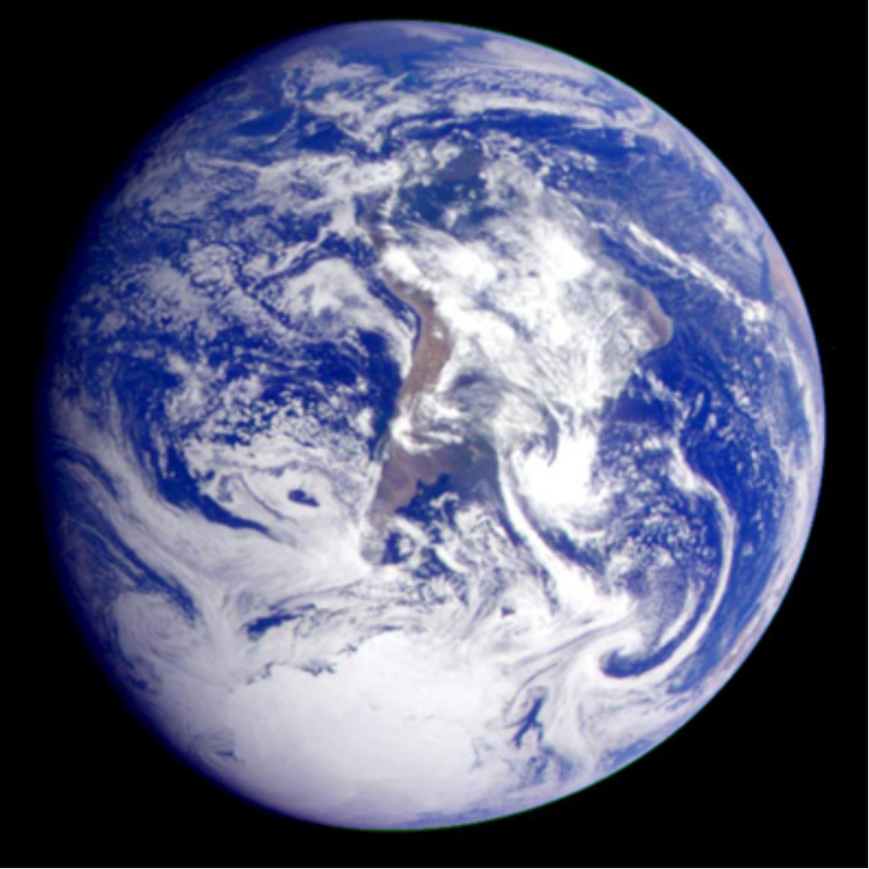Picture 1: In Orbital, players must help evacuate countless inhabited planets, like the one depicted above.

1.1 High Concept

In the science-fiction 2D game Orbital, the player assumes the role of the commander of the Arc, a massive celestial vessel. Using orbital gravity as its only means of acceleration, the Arc must slingshot itself from planet to planet, rescuing billions of colonists before the universe itself ceases to be.

1.2 Story

Evacuate the universe. It’s about to collapse.

Four thousand years in the future, humankind has insinuated itself among the stars. Legions of human beings, inhabiting uncountable galaxies, work to expand their civilization throughout all of existence.

But now that existence is about to end. After centuries of space-folding transportation, quantum engineering, and other dalliances with the building blocks of creation, humanity’s ever-expanding influence has begun to unravel the structure of reality itself. Vast cosmic strings—humanity’s mass transit for decades—have begun to contract around inhabited solar systems, collapsing them into nothing. This crisis has already cost humanity trillions of lives.

The survivors’ only hope is the Arc, a colonization vessel roughly the size of Earth’s moon. Because light-speed engines and other quantum propulsion systems have become unreliable, the Arc must rely on planetary gravity to traverse space, whipping around galaxies and nebulae in order to evacuate systems that have not yet been destroyed by the cosmic crisis. Time is short, and billions must be rescued and find refuge… somewhere else.

1.3 Style and Aesthetics

Orbital is 2D top-down game in which a layer of flat, circular planets overlay a parallax-scrolling field of stars (see Section 2.2 Parallax-Scrolling Background, p. 15). A rapidly moving frustum scrolls over this gigantic background, centering on the planet around which the Arc is orbiting or following the ship as it moves through space.

Though the images used to represent the planets are photorealistic, the highly stylized presentation of 3D space in a 2D environment is meant to evoke the classic arcade aesthetic. The gameplay is fast and furious as the Arc constantly accelerates, always on the verge of shooting off into the depths of space and being lost forever. The music and sound effects hearken to the eight-bit era, with songs full of bleeps and retro synths delivered at a rapid, adrenaline-pumping tempo. The overall pace of the game is one of peaks and valleys. Each level of the game builds up to a neck-breaking crescendo of speed, with a brief respite between peaks as the game slows down for a while at the start of each subsequent level.

Orbital’s story is kept minimal, so as not to detract from the simple play mechanics.

Though basic coordination will get players through the early levels, the ever shortening time limits and increasing speeds will force players to carefully plan their routes through space in order to visit all planets (and avoiding ever more frequent obstacles) and progress to the final stages of the game.

The development and asset acquisition process for Orbital embraces the limitation of using no copyrighted source material. All sound assets were created specifically for Orbital and contain custom or royalty-free samples only. No copyrighted sounds or melodies are used. All art assets were handcrafted for the game, or come from various NASA photography collections. NASA claims no copyright on this material subject to certain restrictions listed at http://images.jsc.nasa.gov/luceneweb/guidelines.jsp.

1.4 Gameplay Mechanics Overview

A single mechanic underlies the entire design of Orbital—a simulation of orbital gravity. The Arc orbits a planet, constantly building acceleration. The player chooses a moment to escape the orbit, and shoots through space on a tangent line determined by the vessel’s current angular momentum. In order to complete a level, the player must guide the Arc from planet to planet using this form of transportation.

The player has three major challenges: First, to visit all available planets within the time limit. Second, the Arc must avoid collisions with comets, nebulae and other dangerous. Finally, the player must maintain control of the Arc as it accelerates to faster and faster speeds, bouncing around the galaxy like a pinball. There are no brakes, no retro-rockets, no way to slow down.

Not that there’s time to slow down—to complete a single level, the player must navigate the Arc to each planet in the system in order to evacuate all colonists. When the Arc makes one full rotation around the planet, the player is rewarded with a cheering sound and a display of the number of lives saved (2-3 billion for a small planet, up to 50 billion for the largest). If the player completes this mission before the time limit is up, he or she moves on to the next stage and the game automatically saves. If time runs out, or the Arc collides with a dangerous object, the cosmic string surrounding the galaxy contracts, crushing the Arc and all the planets into a dense microscopic ball.

Fortunately, the Arc is equipped with two devices to aid in its mission: A force field to deflect comets and survive nebulae, and a relativity engine that allows brief glimpses of “Tangent Time.” During Tangent Time, psychedelic music and colors distort the player’s view of space, but time moves much more slowly, giving the player a short window in which to plan an escape trajectory outside of the game’s usual frenetic pace.

Both the force field and the Tangent Time device are powered by collective psychic energy. The number of colonists already aboard the Arc serves as a battery. If the player relies too much on the force field or Tangent Time, this psychic battery is depleted; more colonists must be rescued before these powers are available once again.

Orbital consists of 25 discrete levels, each larger, faster and more challenging than the last. Progressive levels become more difficult in several ways: more planets, increased distance between planets, more collision objects and shorter time limits. Each level will be laid out by a random algorithm, allowing for many possible levels and enhancing replay. After completing 25 levels of increasing difficulty, the Arc’s mission will be complete, and the new home of humanity will be revealed to the player through a psychedelic cut scene in which the Arc travels to another dimension.

1.5 Orbital Physics

Unlike many 2D top-down games, in which player avatars can move freely in all directions around the screen, Orbital players must rely solely on timing to travel from one place to the next. The Arc, the starship that is the player’s avatar, begins each level of the game in orbit around a planet. By left-clicking the mouse (see Section 4. 1 Game Control Overview, p. 31) the player causes the Arc to shoot through space at a tangent to the their current position in circular orbit, in a direction dictated by whether the Arc is orbiting in a clockwise or counterclockwise direction. While hurtling through space, the player has no way of controlling the path of the Arc.

Each complete orbit around a planet causes a slight increase in the Arc’s acceleration, governed by a level metric that increases as the player progresses through the game (see Section 1.8: Level Progression and Structure, p. 10). The longer the player hesitates to escape orbit, the faster the Arc will move and the harder it will become to estimate the exact path of the escape planet. This gives the player an incentive to act quickly, reinforcing the escalating frenetic pace of the game.
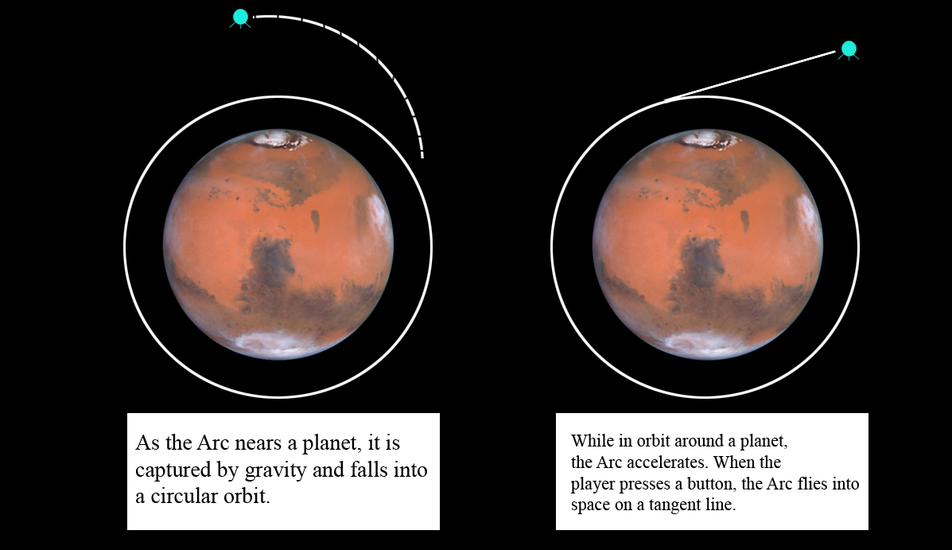

Picture 2: A visual representation of Orbital’s fundamental game mechanic.

As an additional challenge, planets can exert gravity on the Arc. Simulating the Inverse-Square law of gravitation, all planets on a given level exert a slight gravitational pull, the power of which increases exponentially as the Arc nears a planet. Based on the size of the image that represents a given plan, Orbital uses a precomputed lookup table to determine the gravity for a planet of a given radius--larger planets have more powerful gravitational fields. When very near a planet, the Arc will be pulled into orbit, and must escape again on a tangent.

(For a technical explanation of how orbital physics are implemented, see Sections 6.3, p. 43 and 6.4.3, p. 45.)

1.6 Obstacles

Orbital has no “enemies” or “weapons” as such, but it does challenge players with a few obstacles.

Nebulae are clouds of gases hurtling through space. Though they don’t move, a poorly planned trajectory can send the Arc hurtling through one of these dangerous bodies. The player must expend some of the energy of the
Arc’s psychic battery to engage the shields, or else the level will end with the Arc’s destruction.

Comets hurtle through space much like the Arc, getting captured and released from planetary orbits. Comets always leave orbit halfway around the orbit circle, traveling 180 degrees. In other words, if the comet enters a planet’s orbit at high noon, it will leave at 6 o’clock, and in the opposite direction it entered. On levels without cosmic strings, a comet might fly past the bounds of the level. If so, a new comet will enter the system from a random angle, creating in effect a cosmic shooting gallery.

Direct hits between comets and the Arc can be fatal to both. If the Arc has its shields engaged, it can avoid destruction, though it will change directions, bouncing off the comet at an angle opposed to the angle of impact, and half the comet’s speed will be subtracted from the Arc’s, regardless of the angle of impact.

Comets also trail tails. Though these disappear at a rate of 1 pixel length per time slice, they otherwise function like nebulae, requiring shields to bypass. Because comets move and leave these trails, navigation between comet tails becomes an essential skill to complete Orbital.

Black Holes, like Nebulae, are static obstacles, though substantially larger. Even worse, shields will not protect the Arc against their pull. Collision with a black hole spells certain death for the player’s avatar.

To even the odds a bit, the Arc can travel to four types of special planets that provide minor boons for short periods of time. These are detailed in Section 2: Game World (p. 14).

1.7 Game Flow

Each level begins with the name of the solar system depicted in the level, the total number of inhabitants that need rescuing, and a one- or two-sentence tip that describes game play or a short explanation of new features (the level that introduces comets will explain comets, the first level in which a black hole appears will be preceded by an explanation of black holes, etc.). A robotic voice, created using a licensed copy of the Sam Speaks program for the Commodore 64, reads the names of the solar systems and possibly voices the play tip as well.

Each level begins with an animation of the Arc hurtling through space and arriving in orbit around a predetermined planet on the level. After the level announcement plays, the timer starts. The player must guide the Arc past all obstacles to visit all planets before time runs out. If the player is successful, he or she is presented with an opportunity to save the game before moving on to the next level. If time runs out, or the Arc collides with an obstacle, an animation of the ship exploding plays and the player is presented with the option to attempt the level again.

1.8 Level Progression and Structure

The first level is a pregenerated arrangement in which the player should easily be able to navigate to all planets and get a feel for the gameplay of Orbital. This de facto tutorial level will be laid out in a mostly linear manner similar to an actual solar system (see Picture 3, top of p. 10).
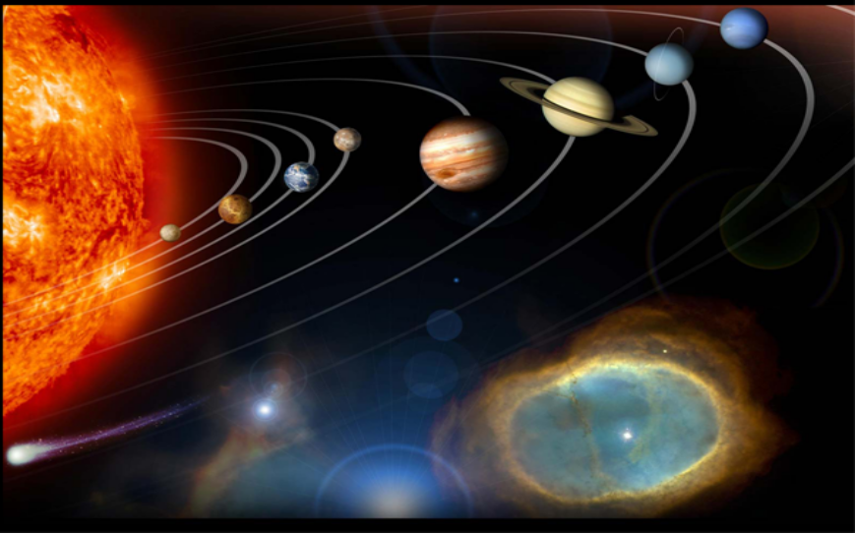
Picture 3: Template for first level (note nebula at lower right).

The subsequent 24 levels are generated by a random algorithm that relies upon escalating metrics to increase the challenge of the game.

Early levels are surrounded by a cosmic string, a wavy, glowing white line that prevents the Arc from flying past the bounds of the level (in which circumstance the level would end in defeat for the player). If the Arc hits a cosmic string, it distends then whips back into shape, reversing the Arc’s direction and increasing its acceleration by 50%, though the player does not lose the level. This cosmic string disappears after stage 10—going forward, a poorly timed escape from orbit can send the Arc hurtling off into space.

The other escalating metrics used to generate levels are summarized in the following table:

Metric | Explanation | Formula
Size of Level | Larger amounts of empty space increase likelihood of planet-misses and collisions with objects. | 10%/LVL
Distance between Planets | Longer paths are harder to estimate and increase likelihood of collisions. | +15%/LVL
Time Limit | Less time to complete level, relative to increasing challenge. | +8%/LVL
Number of Planets | More locations to visit in less time. | +10%/LVL
Freq. of Nebulae | Increased chance of collision. | +10%/LVL
Freq. of Comets | Increased chance of collision. Tails elongate as well. | +5%/LVL
Freq. of Black Holes | Increased chance of collision | +1 Black Hole/5 LVLs
Base Speed | Faster speeds reduce controllability. | +5%/LVL
Acceleration Rate | Navigation becomes more difficult earlier in the level. | +5%/LVL
Cosmic String | Safety net removed after level 10. | N/A
Table 1.1: Escalating Difficulty Metrics for Orbital Levels.

1.9 Winning the Game

If the player completes all 25 levels, a victory cut scene plays. This animation consists of three captioned still shots specially commissioned from Los Angeles comic book artist Cesare Tatarelli. The Arc travels to an uninhabited universe and humanity is given a chance to prosper once again.

1.10 Player’s Avatar: The Arc

The Arc is as large as the smallest planet in Orbital’s planet set (see Section 2: Game World, p. 14). It is enormous, capable of holding billions of people, and possesses a psychic battery that uses the collective will of its inhabitants to power shields and a special play mode called Tangent Time. For every billion people saved, its psychic battery recharges 1 point.

1.10.1 Shields

Shields allow the Arc to survive collisions with nebulae, comets, and comet tails. The player must time the deployment of his shields properly—expend them too early and psychic battery points are wasted; too late, a collision occurs.

Shields deplete the Arc’s psychic battery at a rate of 5 points per second.

1.10.2 Tangent Time

Tangent time simulates a massive slowdown in the space-time continuum. In terms of game mechanics, it reduces the velocities of all moving objects by 90% and freezes the game clock, allowing Tangent Time to be easily implemented without going into the vagaries of adjusting frame rate, clock speed, etc.

When the Arc enters tangent time, a saturation filter is layered over the displaying, turning various regions of the screen into areas of scintillating psychedelic color. A slight “heat distortion” effect creates ripples over the screen. This is accompanied by sitar music and a voice saying “Tangent Time” in a slowed-down then sped-up tempo. These aesthetics are a cute way to convey to the player the idea that they are fussing with the fundamental rules of reality.

Tangent Time depletes the Arc’s psychic battery at a rate of 10 points per (real) second.

For implementation and control details of shields and Tangent Time, see Section 4.1: Game Control Overview, p. 31.

SECTION 2: GAME WORLD

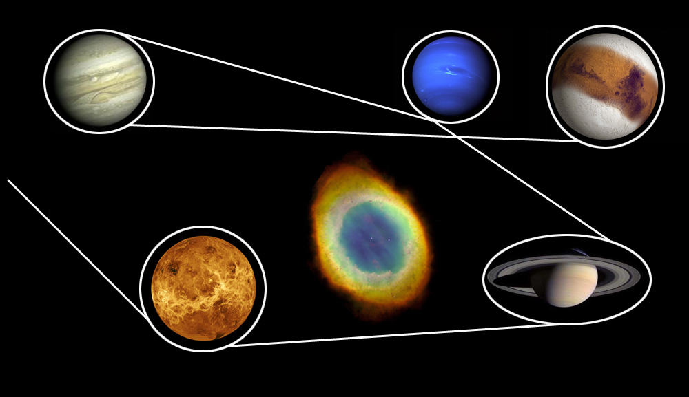
Picture 4: The white line shows one possible path through a hypothetical level of Orbital.

2.1 Game World Overview

Each level of the game takes place within a single galaxy. Space is represented in a top-down 2D view. Planets and obstacles maintain static positions in the foremost layer, which the Arc and one or more comets bounce around. In the background, three layers of starry nothingness scroll in a parallax fashion, creating the illusion of a vast void.

Picture 4 on the previous page is a diagram of a sample level of Orbital. For clarity, only the foremost layer is depicted. In this hypothetical level, the player must avoid the nebula in the center of the map and reach all planets before time expires. The Arc enters from the left edge of the level and begins circling the bottom-leftmost planet. The white line describes one possible course to all planets that also avoids the central nebula. Note that the Arc cannot reverse the direction of its orbit when it circles a planet.

2.2 Parallax-Scrolling Background

The topmost layer of the game screen consists of the planets, obstacles and the Arc itself. Beneath this layer are three layers of starry space that scroll in a parallax fashion. These three layers are generated randomly at runtime from regions of the base star bitmap (see Picture 6 below, p. 25).

2.3 Special Planets

Because there are no real “enemies” or “weapons” in Orbital, much of the game’s flavor and variety comes from the assortment of planets that populate the 25 levels of the game.
There are no “enemies” as such in Orbital. The only real enemies are acceleration, the clock and dangerous celestial bodies such as comets and nebulae. That said, a few planets have beneficial effects. Dangerous and beneficial bodies are listed below:

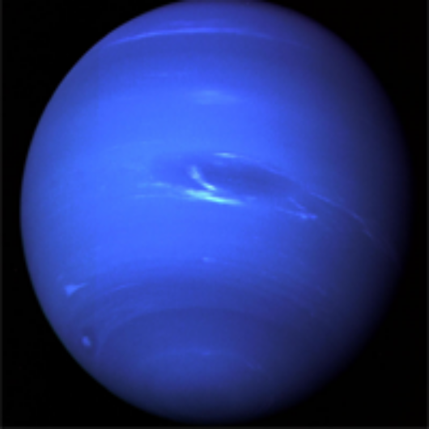Blue Planets

Blue planets will reduce the Arc’s speed by 10% after the vessel makes one complete orbit around the planet.

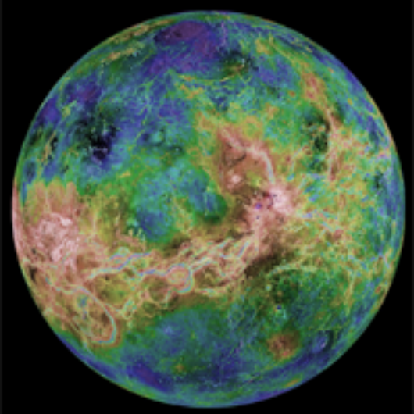Green Planets

Green planets teem with life, allowing a small recharge to the psychic battery that powers the Arc’s force field and Tangent Time engine.

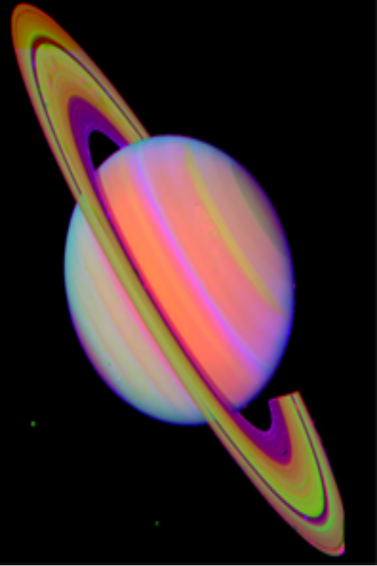Ringed Planets

Ringed planets cause a temporary state of indestructibility for the Arc, and also forces it to reach maximum acceleration. The musical score will change to a particularly frenetic melody as the Arc bounces around the level at ludicrous speed, bypassing any black holes, comets or nebulae it encounters for the next 15 seconds.

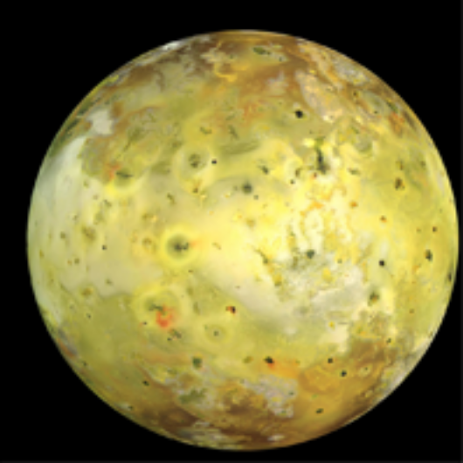Gold Planets

For 15 seconds, the tangent line from the Arc’s current position will display, much like the “cheat mode” in some pool hall simulations that show the path all balls on the table will take if a certain shot is executed. These lines will display in the main screen as well as on the map, allowing the player to see with certainty the available paths to other planets.

2.4 Obstacle Representations

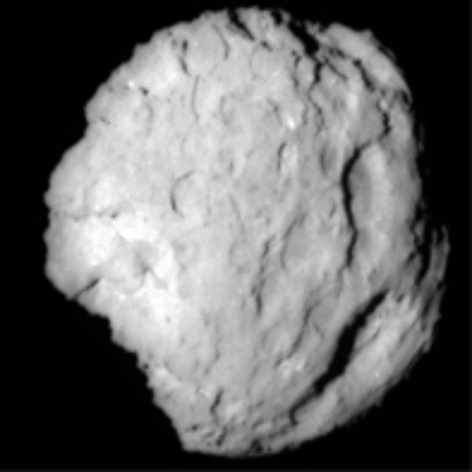Comets

Comets bounce around the levels and slowly increase their acceleration, though not as much as the Arc does. If the Arc collides with a comet, the level is over and the player must restart. But if the player activates his or her shields before impact, the comet explodes with a pleasing ka-boom and a blinding flash of white light that fills the screen.

Cosmic Strings

Because of the fast pace of the game, it’s likely that the player will miscalculate the moment of release and send the Arc hurtling off into space. To avoid this possibility, early levels are surrounded by a glowing white cosmic string that undulates as if it is floating in water. If the Arc collides with the string, the string distorts then returns to its original shape, sending the Arc hurtling backward along its original path—and at much greater speed. If the time limit for the level runs out, this ring collapses, smashing all the planets together and grinding the Arc between them.
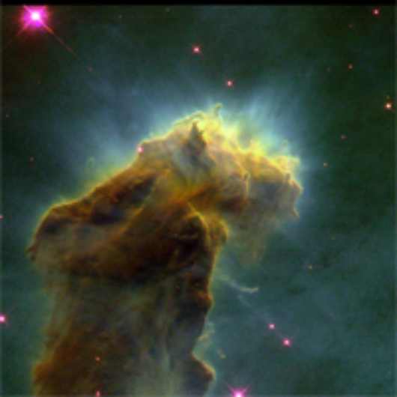Nebulae

If the Arc flies through one of these gaseous giants, the vessel is destroyed. If the player activates the force field before crossing the body, a sizzling sound plays but the Arc will survive. Nebulae do not exert gravitational pull on the Arc.

(continued on next page)

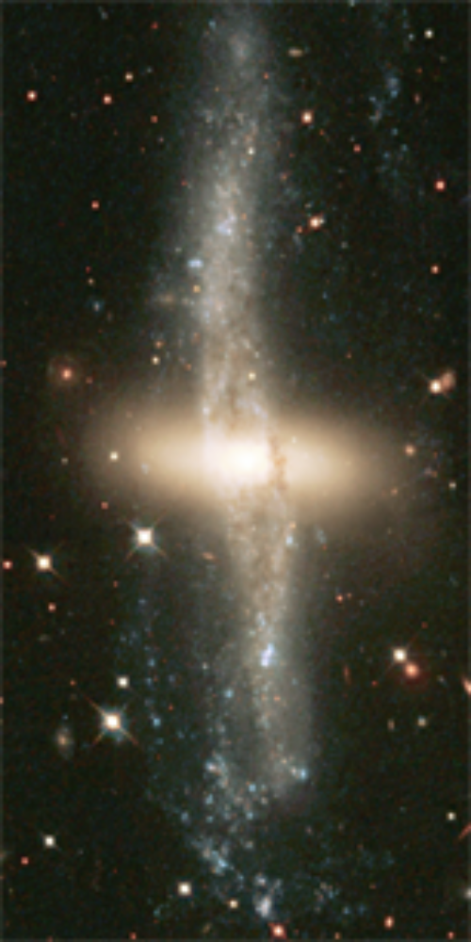Black Holes

Black holes exert their own gravity and cannot be bypassed by using the force field. Black holes present a dangerous opportunity to the player: They might be useful for changing course, but if the Arc gets too close, it is sucked inside and the level ends.

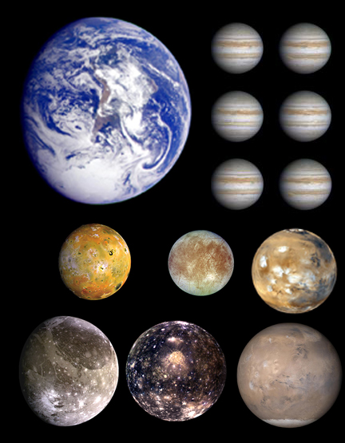
SECTION 3: GAME TEXTURES AND BACKGROUND

Picture 5: Sample planet sprites for Orbital.
3.1 Image Sources

NASA’s Jet Propulsion Laboratory has made available a number of public domain images that can be used without copyright concerns. Several thousand photographs of planets, nebulae, comets and other celestial bodies are available through the www.jpl.nasa.gov website, giving the Orbital team plenty of visuals to pick from. The demo version of the game will contain 50 or so different planets, and a dozen or so nebulae, comets, black holes, etc.

The game screen itself will be as uncluttered as possible to allow for the largest possible view of “the majesty of space.” At the top center of the screen, a small map will show the entire layout of the level, much like in the arcade classic Defender. The player’s current score will be displayed in the bottom left hand corner.

The next page features a collection of planets already being prepared for use in Orbital.

The three background bitmaps are used to create parallax scrolling below the foremost level of the game, which contains the Arc and the planets. Nebulae are static foreground obstacles that destroy the ship if it passes through them without shields activated.

These are the heart of the game—a wide variety of beautiful planet shots available through NASA. Because there are so many different planets involved, the following lists are broken up by category—different planets grant different bonuses for the player.

All planetary images are static, single frame entities.

3.2 Image Formats

All images for Orbital will be 32-bit bitmaps, and stored in a Windows resource file to allow the game to be packaged as a discreet executable.

3.3 Image Catalogue

The following sections list the necessary assets for Orbital.

3.3.1 Animated Art Assets

Table 3.1 lists all animated assets necessary to complete Orbital. For specific information on the Arc animations, see Section 3.3.4: The Arc, p. 28.

Because the cosmic string that surrounds the level will be different sizes depending on how far into the game the player has progressed, a few variations on the “wavy white string” are included to provide visual interest. These sections are then scaled to the size of the level and joined according to the new proportions of the circle formed by these segments. The cosmic string distends when the player’s ship collides with it—this stretching is displayed programmatically using the building block bitmaps for the edge and tip provided below.

Table 3.1: Animated Art Assets
NAME | DESCRIPTION | FILE NAME | FRAMES
The Arc -- In Flight | Spaceship flying through space | anim_arc_move.bmp | 24
The Arc -- Explosion | Spaceship fragmenting after collision | anim_arc_death.bmp | 6
Black Hole | Black Hole spinning about Z-Axis | anim_blackhole.bmp | 12
Comet -- In Flight | Flaming comet, animated tail | anim_com_move.bmp | 12
Comet -- Explosion | Comet bursting apart | anim_com_death.bmp | 6
Cosmic String 1 | building block for level boundary | anim_cs_1.bmp | 3
Cosmic String 2 | building block for level boundary | anim_cs_2.bmp | 3
Cosmic String 3 | building block for level boundary | anim_cs_3.bmp | 3
Cosmic String 4 | building block for level boundary | anim_cs_4.bmp | 3
Cosmic String 5 | building block for level boundary | anim_cs_5.bmp | 3
Cosmic String 6 | building block for level boundary | anim_cs_6.bmp | 3
Cosmic String Edge | CS distends when player collides | anim_cs_edge.bmp | 1
Cosmic String Tip | Surrounds outer Arc during distend | anim_cs_tip.bmp | 1
Arc shields | Blue energy that surrounds the ship | anim_shields.bmp | 3

3.3.2 Environmental Art Assets

The three background bitmaps are used to create parallax scrolling below the foremost level of the game, which contains the Arc and the planets. Nebulae are static foreground obstacles that destroy the ship if it passes through them without shields activated.

Table 3.2: Environmental Art Assets
NAME | DESCRIPTION | FILE NAME
bottommost background | sparse stars on blackness | back1_void.bmp
middle background | field of stars and gases, used for parallax | back2_neb.bmp
uppermost background | Field of stars; used for parallax scrolling | back3_star.bmp
nebulae 1 | gases in space | neb_1.bmp
nebulae 2 | gases in space | neb_2.bmp
nebulae 3 | gases in space | neb_3.bmp

Picture 6, on the following page, is the base star bitmap. By used sections of this bitmap, Orbital generates the three layers for the parallax scrolling:

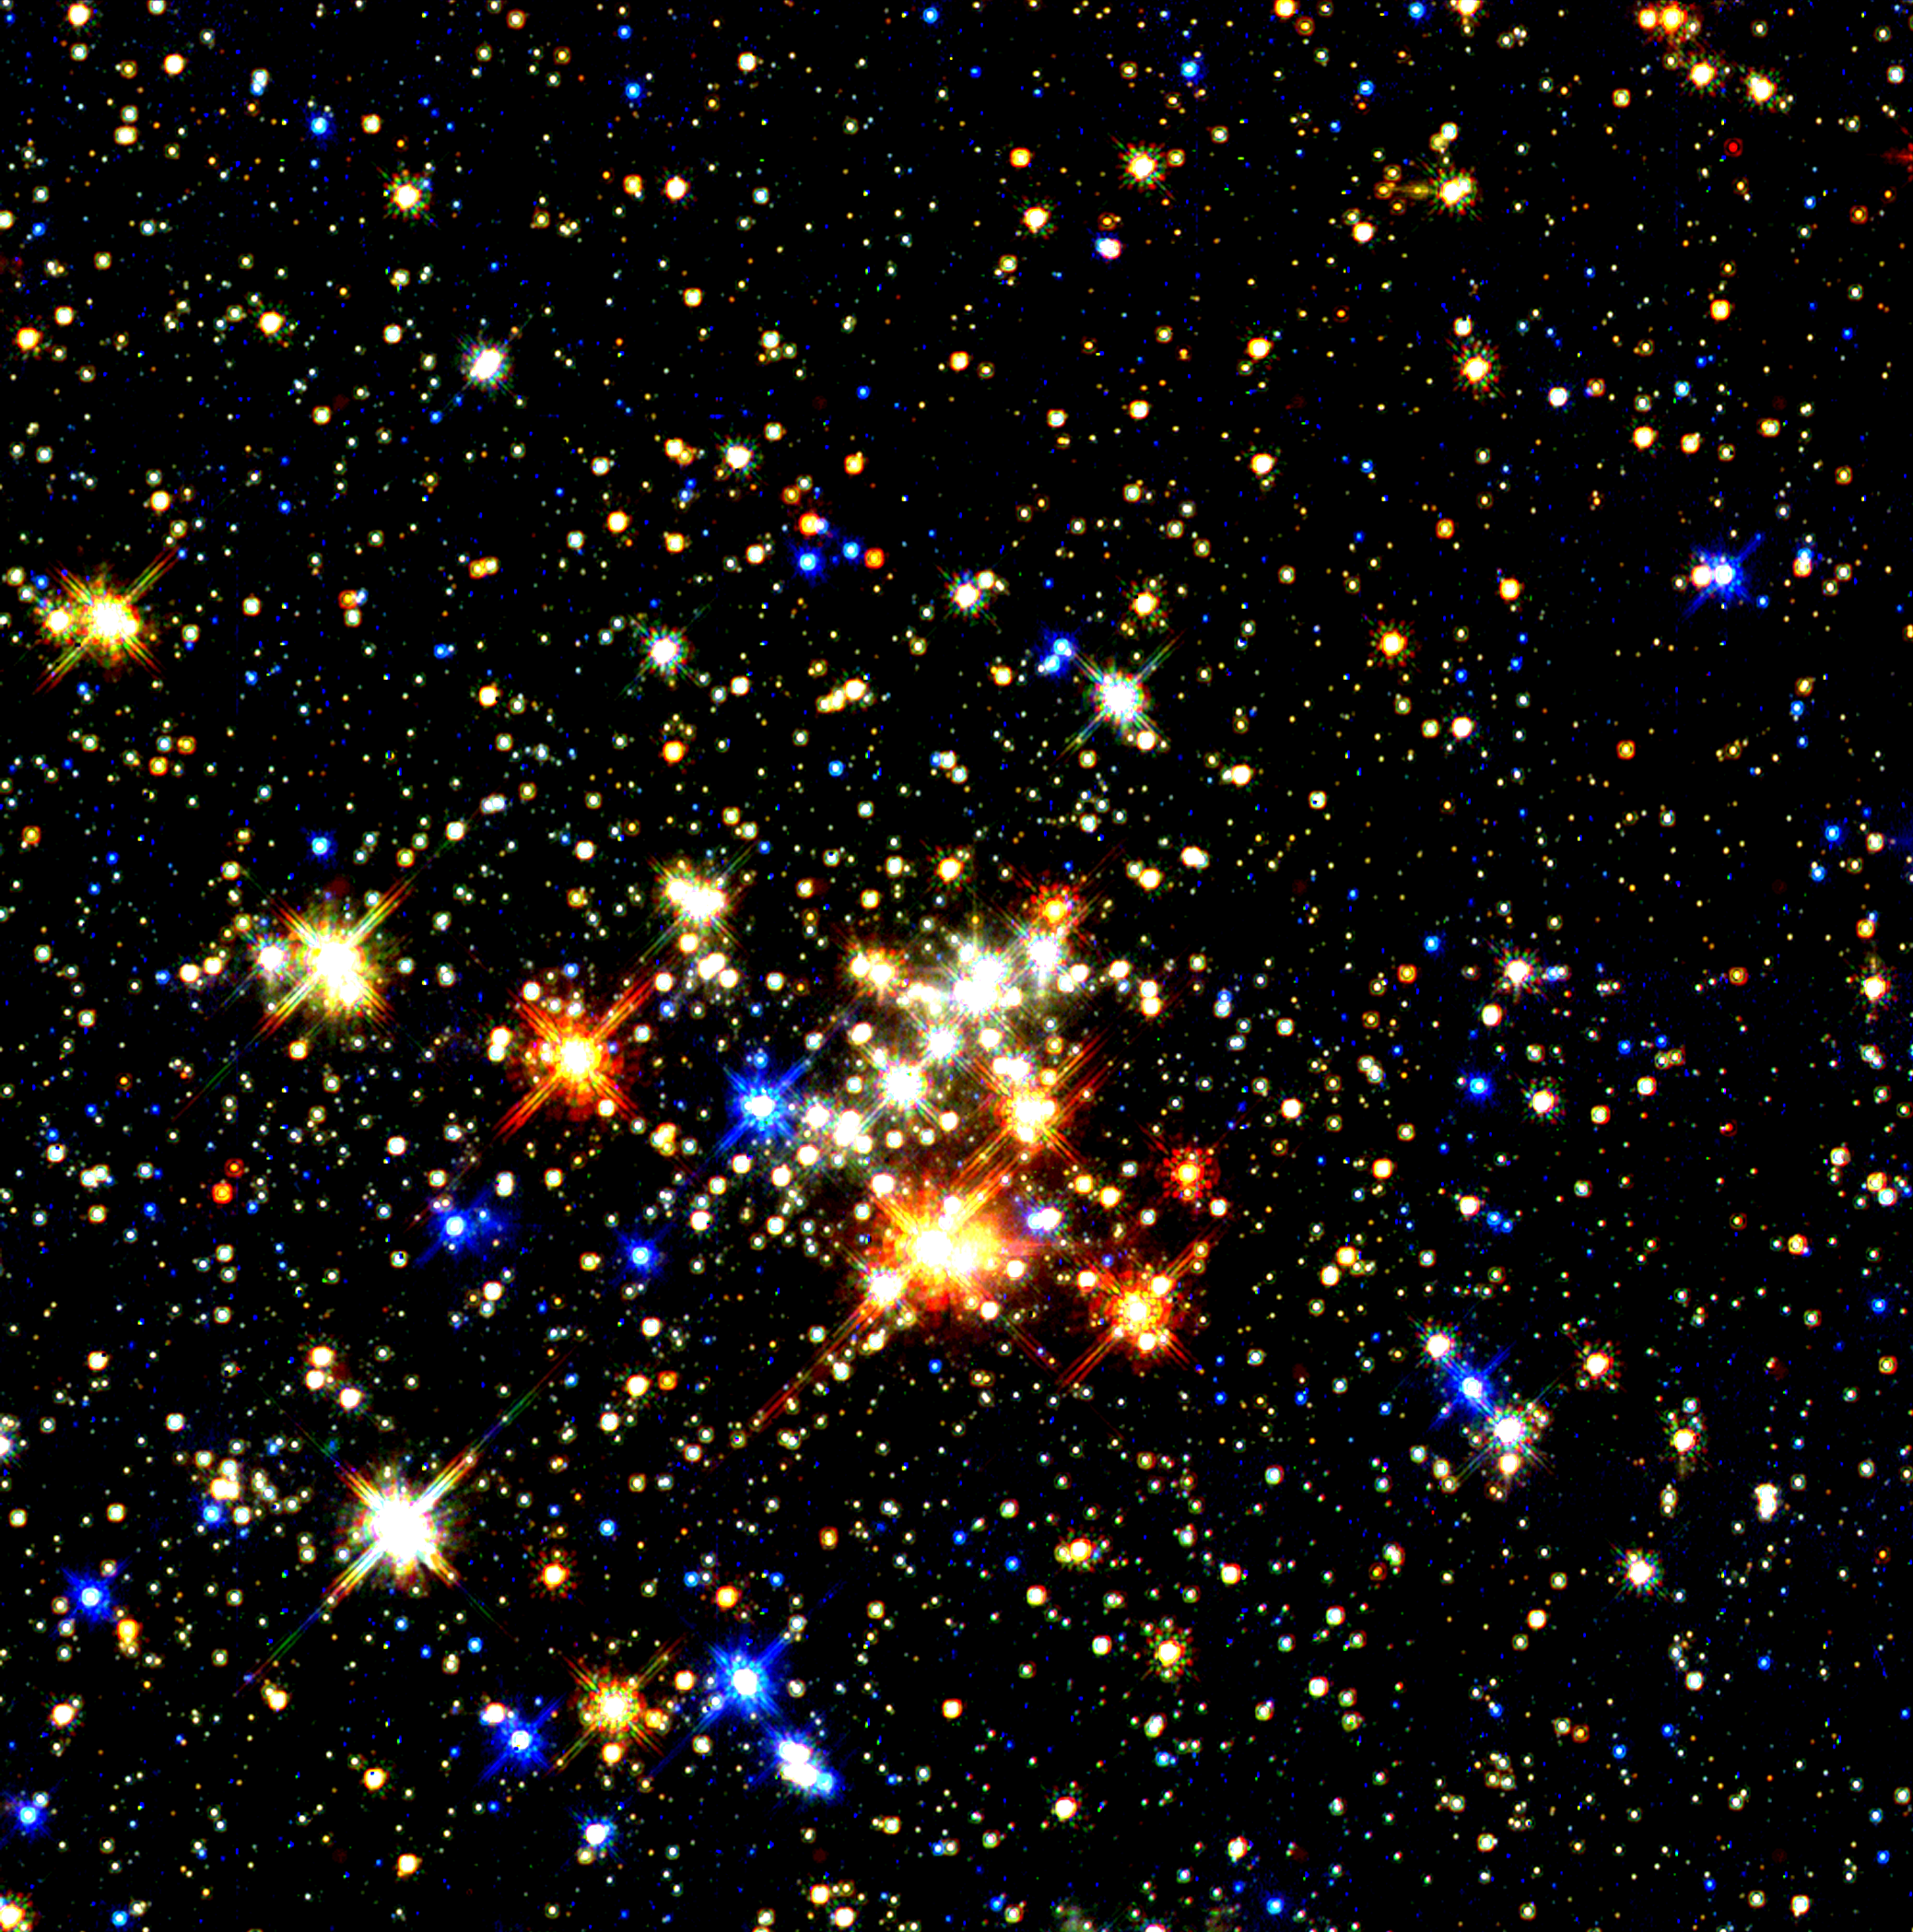
Picture 6: Base star bitmap; scrolling layers of background generated from this image.

3.3.3 Planet Art Assets

These are the heart of the game—a wide variety of beautiful planet shots available through NASA. Because there are so many different planets involved, the following lists are broken up by category—different planets grant different bonuses for the player.

All planetary images are static, single frame entities.

Gold Planets

Gold planets are very rare—they allow the player to see tangent lines from their current orbit for 15 seconds.

Table 3.3 Gold Planet Art Assets
NAME | DESCRIPTION | FILE NAME | NAME
Uranus | Gold-hued planet | p_gold_1.bmp | Uranus
Uranus 2 | Another view of Uranus | p_gold_2.bmp | Uranus 2
Sun | High contrast view of Sol | p_gold_3.bmp | Sun
unknown planet | yellowish planet | p_gold_4.bmp | unknown planet
Titan | Moon of Saturn | p_gold_5.bmp | Titan

Green Planets

Green planets recharge the battery that powers the Arc’s shields.

Table 3.4 Green Planet Art Assets
NAME | DESCRIPTION | FILE NAME | NAME
Venus | the planet venues | p_grn_1.bmp | Venus
Venus 2 | another view of venues | p_grn_2.bmp | Venus 2
unknown Saturn moon | small greenish planet | p_grn_3.bmp | unknown Saturn moon
altered Neptune | Neptune with green saturation | p_grn_4.bmp | altered Neptune
hypothetical mars | mars w/ vegetation model. | p_grn_5.bmp | hypothetical mars

Blue Planets

Blue planets reduce the speed of the Arc.

Table 3.5 Blue Planet Art Assets
NAME | DESCRIPTION | FILE NAME | NAME
Neptune | the planet Neptune | p_blu_1.bmp | Neptune
Neptune 2 | the planet Neptune | p_blu_2.bmp | Neptune 2
Neptune 3 | the planet Neptune | p_blu_3.bmp | Neptune 3
Neptune 4 | the planet Neptune | p_blu_4.bmp | Neptune 4
Neptune 5 | the planet Neptune | p_blu_5.bmp | Neptune 5
Europa | Moon of Jupiter | p_blu_6.bmp | Europa
Pluto | the planet Pluto | p_blu_7.bmp | Pluto

Ringed Planets

Ringed planets make the player indestructible for 15 seconds.

NAME | DESCRIPTION | FILE NAME
Saturn | the planet Saturn | p_rng_1.bmp
Saturn 2 | the planet Saturn | p_rng_2.bmp
Saturn 3 | the planet Saturn | p_rng_3.bmp
Saturn 4 | the planet Saturn | p_rng_4.bmp
unknown Neptune Moon | small ringed planet, red | p_rng_5.bmp

3.3.4 The Arc

The Arc—the player’s spaceship—as well as black holes and comets, are stored as two-dimensional grids of 64 x 64 pixel bitmaps that the game’s Bitmap class divides into 24 individual frames of animation that can be played forward or backward to represent clockwise or counterclockwise rotation..
Picture 7, on the following page, represents the current version of the Arc’s graphics. These will likely receive an overhaul before the Orbital demo is released.

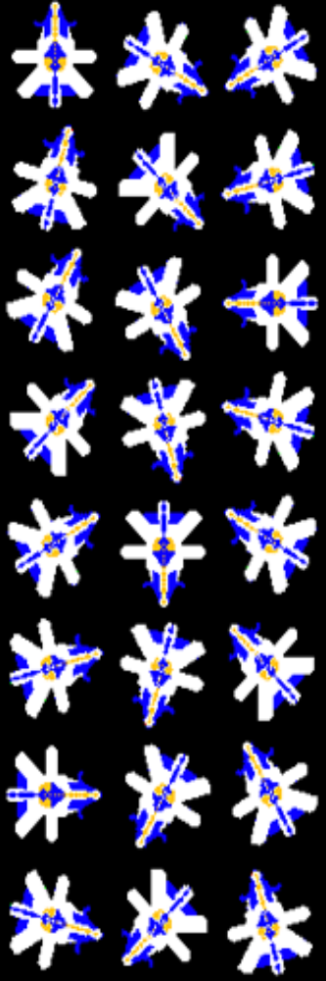
Picture 7: Programmer artist’s conception of the Arc.

SECTION 4: USER INTERFACE

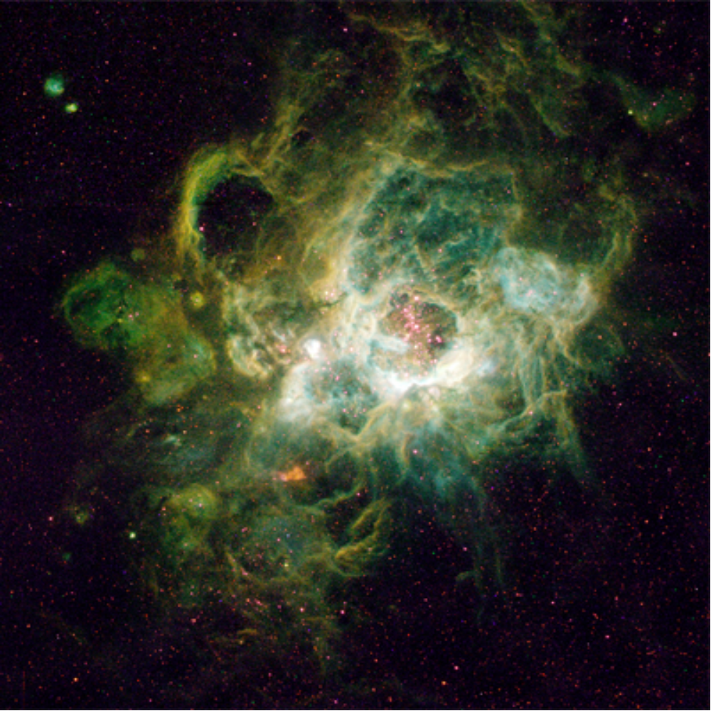
Picture 8: Orbital Players will use controls to avoid obstacles such as gaseous nebulae, depicted above.

4.1 Game Control Overview

Players can use the mouse or keyboard to control the Arc’s voyage through the galaxies of Orbital. After refining the control scheme through several revisions, the final version that will appear in the demo is the essence of simplicity, requiring only two buttons to control every action in the game.

Conceptually, the Arc can be in one of two states during the game itself: In orbit around a planet, or traveling between planets. The actions resulting from a button press are context sensitive and have different outcomes depending on which of these two states the Arc is currently in.

If the Arc is orbiting a planet, single-clicking the left mouse key (or the spacebar, if using the keyboard) will cause the Arc to escape orbit along a tangent to their current position. The direction of escape will depend on the direction in which they are orbiting the planet: If orbiting clockwise, the Arc will escape with a positive-x (eastward) direction if the left key is pressed at the top of the orbit circle. If the Arc was traveling counterclockwise, it would travel toward negative-x (westward) if escaping from the top of the orbit circle. Double-clicking will have the same result in this circumstance as a single click.

If the Arc is traveling between planets (i.e., not in orbit around a planet), the left mouse key does nothing. This reinforces the core game mechanic of hurtling through space: The player will only be able to choose his or her course through a level while orbiting a planet, by carefully timing the release from orbit.

The outcome of clicking and holding the right mouse button (or pressing and holding the CTRL button, if using the keyboard) is likewise context-sensitive. If the player is in orbit around a planet, clicking and holding the right mouse button will put the Arc into Tangent Time (see section 1.10.2, p. 13). The game will remain in Tangent Time mode until the Arc’s psychic battery is depleted, or until the player releases the right mouse button.

If the Arc is traveling between planets, clicking and holding the right mouse button will engage the ship’s shields. While shields are engaged, gameplay is affected in several ways: The Arc will be able to pass through nebulae and the tails of comets without being destroyed, and can survive a direct collision with a comet, though its course will be altered. The only thing the shields will not protect the Arc from are black holes.

Shields remain active until the Arc’s psychic battery is depleted or the player releases the right mouse key. A spinning circular animation representing the shields will appear around the Arc until the shields are disengaged.

Orbital also features DirectPlay support for any 2+ button game pad. Using DirectPlay, button 1 on the control will correspond to the left mouse button, button 2 to the right mouse button.

ACTION | MOUSE | KEYBOARD | GAMEPAD
Escape Orbit | Left Button | Space Bar | Button 1
Shield/Tang. Time | Right Button | CTRL key | Button 2
TABLE 5.1: CONTROL SCHEME FOR ORBITAL

4.2 Additional Controls

Aside from the in-game controls, pressing the ESC key at any time will return the game to the main menu (see Game Flowchart below, p. 37). If the player is currently playing a level, the game will pause until the player chooses an option from the menu or presses the ESC key again. The player can also reach the main menu via ESC from any other screen in the game, such as the save or load screens. Pressing ESC while on the main menu will prompt to player to confirm that he or she wants to exit the game entirely.

All menu navigation will take place via moving the mouse and left-clicking to make a selection. If the player is using a gamepad, selections can be made by moving the cursor via a joystick or direction pad and confirming them by clicking button 1.

During the save menu screen, the player might opt to enter a file name for a saved game, which will require keyboard input.

4.3 Cheat/Debug Codes

To aid in debugging the game, as well as demonstrating it before an audience, several cheat codes will be enabled to ease access to certain portions of the game. By pressing CTRL+ALT+C on the keyboard, cheat mode will be activated, and display a message on the screen in the standard text blitter font (see 6.4.2: Menu Subsystem, p. 45): “CHEAT ENGINE ENGAGED!” Though no dialogue box or text prompt will appear, a keyboard input parser will be active, looking for strings of characters that will active certain game features, which are described below:

CODE | EFFECT
skipX, X = 1 - 9 | Skips X number of levels. If > max level, shows endgame sequence.
end | Show endgame sequence.
psybat | Unlimited psychic battery.
nodie | Unlimited invulnerability.
freeze | Freezes game clock; unlimited time to finish level.
god | Combines psybat, nodie, and freeze cheats.
noacc | Arc maintains beginning acceleration, will not accelerate
die | The Arc explodes, ending the level.
fps | Displays current frame rate.
TABLE 5.2: ORBITAL CHEAT CODES

4.4 In-Game HUD

Following Richard Rouse’s advice, Orbital will contain a minimal HUD, consisting of a small bar that occupies the lower 1/8th of the screen.

During most of the game, the HUD bar will display, from left to right: time remaining, current score, and a small square map representing the current level. The font used for this bar is OCR A Extended (the same font used for all headers in this document.

When the player engages either shields or Tangent Time, an animation makes the bar flip vertically about its x-axis; replacing the remaining time and current score, a horizontal bar will appear, providing the player with a visual representation of the Arc’s remaining psychic battery strength. As shields or Tangent Time continues to be engaged, this bar will deplete from right to left. If the bar is fully depleted, the animation will flip the bar back over to its default setting. Note that visiting planets will replenish this bar. (see Section 1.10 above, p. 12).

The map of the level remains persistent no matter which state the HUD bar is currently in. Because planets may sometimes be off-screen given the Arc’s current position (especially during later levels), this map will ease navigation through larger levels and hopefully reduce player frustration. The map will be a small square, twice as large as the HUD bar. Because the entire level will be blitted to the backbuffer, an image of the entire level can be scaled and used for this map.

Planets on the HUD map will initially be depicted brighter than they appear in the game proper. After the Arc has visited a planet, the image in the map will darken, allowing the player to easily see which planets remain to be visited in order to complete the level.

4.5 Screen and Menu Navigation

Table 5.3 on page 37 provides a flowchart that summarizes the most important menus and screens of Orbital. (Not depicted are the “credits” and “how to play” screens, described below.) After the player loads the game, the following screens will display:

Production Logos: The first production logo fades in from a black screen when the game is loaded. Three full-screen logos appear in sequence, for about 10 seconds apiece. The first logo is the mock production company The Boys in the Lab Are Gonna Have a Field Day With This One Productions, which features some nerdy-looking Guildhall students staring aghast at a glowing computer screen. The next logo fades in: Supported by The Programmer Art Foundation, with a particularly poorly drawn stick figure wielding bloody swords, rendered on notebook paper. The third logo screen features the Guildhall logo itself.

A 30-second music clip accompanies the production logos. The production logo sequence can be bypassed at any time by pressing the ESC key.

Title Screen: After the production logos have been displayed, the screen goes dark again. Twinkling music plays over blackness, but is quickly swamped by the roar of what might be the engine of a huge starship. The letters of the Orbital logo fade in along with the ringed-planet symbol (see the cover page of this design document).

After all the letters appear, the main menu displays. Like the production logo sequence, the title sequence can be bypassed at any time by pressing the ESC key.

Main Menu: After the player watches the production logo and title sequences, or after he or she presses the ESC key, the main menu appears. It is exactly like the full title screen except that several game options appear: New Game, Load Game (if any saved games exist), Credits, and Quit. The text on the main menu telescopes and shrinks: mousing over an option will make it appear larger than the other options, and a sound cue will let the player know that a new option has been picked. Left clicking on the option will playing a confirmation sound cue and change the game state to one of the subsequent screens:

Load Game Screen: Displays a scrollable list of save games, arranged by date. Each entry lists the name of the saved game and the date it was created. Like the main menu, mousing over a saved game entry will telescope the text and play a sound cue. Clicking on an entry will load the associated save game file and put Orbital in game mode. A confirmation sound cue lets the player know that a choice has been acknowledged. Pressing the ESC button or clicking on the main menu icon in the lower-righthand corner of the screen will return the player to the main menu.

Credits Screen: Lists the names of everyone who contributed to Orbital, along with URLs for the Guildhall and Orbital websites.

Game Mode: After the player chooses the New Game option on the main menu screen, or after loading a game on the load game screen, Orbital enters game mode. This is where the actual game play happens. The first level will load, or the level on which the player saved his or her game will load and follow the usual sequence for a level. If the player chose the New Game option, a short “how to play” screen appears before going to the first level. Like a classic arcade game, this screen provides a one-sentence summary of the game: “Visit all planets before time runs out to progress to the next level.” The game controls are also briefly summarized with appropriate visual representations: “Left click escapes orbit.” “Right Click In Space: Engages Shields.” “Right Click In Orbit: Tangent Time!” The “how to play” screen prompts the player to press any key to continue on to the first level.

Save Game Screen: After each level is completed, the player will be given the option to save his or her game. This is the only time in Orbital that a game can be saved—saving isn’t possible during the actual game, because the levels typically two to four minutes long. If the player opts to save, they will be taken to the save game screen. This screen behaves exactly like the load game screen except that it has a “new save game” option. Clicking on this option will allow the player to enter the name for the save game. Otherwise, clicking on an existing save game will display a dialog box asking the player whether he or she wants to save over this existing file.

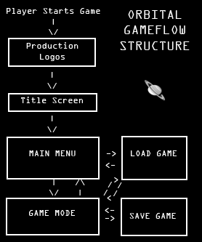
Table 5.3: Game State Flowchart for Orbital
SECTION 5: SFX AND MUSIC

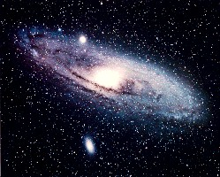Picture 9: Many levels of Orbital will be laid out like a spiral galaxy, shown above.

5.1 Sound and Music Overview

Except for a few menu sounds, all sound assets for Orbital are complete. Once the menu sounds are finished, all sounds will be normalized in a licensed copy of Cool Edit Pro 2 and added to the game.

All background music was created by Orbital’s designer, as well as local musicians Austin Meyers and Melissa Brannan.

5.2 Music

To capture the intended classic arcade feel, all music in Orbital will sound very Atari—lots of blips and bleeps.

Table 5.1: Music Assets
NAME | DESCRIPTION | FILE NAME
intro vamp | music over fake production company logos | intro.mp3
title music | short loop to play over title screen and main menu | title.mp3
game music | looped retro arcade synth madness | game.mp3
tangent time music | trippy psych music for this mode of play | ttime.mp3
victory music | very short fanfare upon game completion | victory.mp3

5.3 Sound Effects

The following list includes menu and in-game sound cues.

Table 5.2: SFX Assets
NAME | DESCRIPTION | FILE NAME
menu click | plays when player pages through options | menu_click.mp3
menu_confirm | plays when player makes a selection | menu_conf.mp3
launch sound | plays at the beginning of each level | game_start.mp3
release sound | plays whenever ship leaves an orbit | game_tangent.mp3
nebula death | hissing when ship hits nebula | game_death_neb.mp3
black hole death | sucking sound when ship hits black hole | game_death_bh.mp3
comet death | sound when comet explodes (against shield or ship) | game_death_comet.mp3
cosmic string stretch | plays as cosmic string stretches | game_cs_stretch.mp3
cosmic string snap | "boing" sound as cs snaps back into shape | game_cs_snap.mp3
rescue sound | cheer when ship clears a planet | game_rescue.mp3
invulnerability vamp | fast tempo cue that ship is invincible | game_invuln.mp3

5.4 Level Announcements

At the beginning of each level, a ridiculous robot voice will announce the name of the solar system and its number of inhabitants. Each of these voice files was produced with a licensed copy of SAM SPEAKS, a legacy speech synthesis engine for the Commodore 64.

Table 5.3: Level Announcement Assets
NAME | DESCRIPTION | FILE NAME
"Sol System" | level 1 announcement | spch_1.mp3
"Aquarius Dwarf System" | level 2 announcement | spch_2.mp3
"Barnard's Galaxy System" | level 3 announcement | spch_3.mp3
"Fourcade-Figuero System" | level 4 announcement | spch_4.mp3
"Centarius System" | level 5 announcement | spch_5.mp3
"Burbridge Chain System" | level 6 announcement | spch_6.mp3
"Pinwheel Galaxy System" | level 7 announcement | spch_7.mp3
"Coddington's Nebula System" | level 8 announcement | spch_8.mp3
"Kowal's Object System" | level 9 announcement | spch_9.mp3
"Integral Sign Galaxy System" | level 10 announcement | spch_10.mp3
"Mice System" | level 11 announcement | spch_11.mp3
"Pancake System" | level 12 announcement | spch_12.mp3
"Capricorn Dwarf System" | level 13 announcement | spch.13.mp3
"Grus Quartet System" | level 14 announcement | spch_14.mp3
"Hardcastle's Galaxy System" | level 15 announcement | spch_15.mp3
"Harrington-Wilson System" | level 16 announcement | spch_16.mp3
"Miniature Spiral System" | level 17 announcement | spch_17.mp3
"Draco Dwarf System" | level 18 announcement | spch_18.mp3
"Keenan's System" | level 19 announcement | spch_19.mp3
"GR 8 System" | level 20 announcement | spch_20.mp3
"Triangulum Galaxy System" | level 21 announcement | spch_21.mp3
"Copeland Septet System" | level 22 announcement | spch_22.mp3
"Black Eye Galaxy System" | level 23 announcement | spch_23.mp3
"Carina Dwarf System" | level 24 announcement | spch_24.mp3
"Exclamation Mark System" | level 25 announcement | spch_25.mp3

SECTION 6: TECHNICAL SPECIFICS

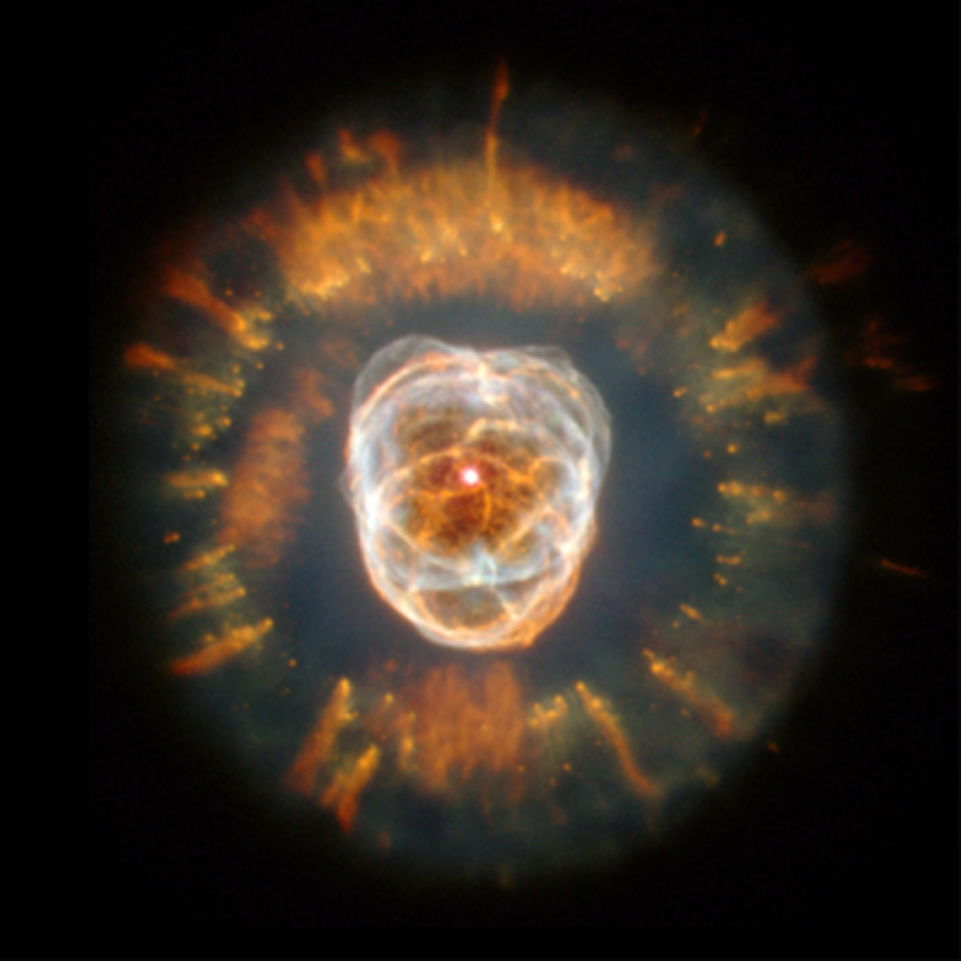Picture 10: Artist’s conception of the entire universe, from NASA’s Jet Propulsion Lab.

6.1 Hardware Requirements

Orbital is designed for a Windows XP system with a 2 GHz processor and 1 gigabyte of RAM memory, with at least 200 megabytes of hard-drive space available. The video card must support a resolution of 1024 x 768 in 32-bit color. Sound card is optional but recommended. DirectX is not required, except for game pad support.

In practice, Orbital will run with much lower system requirements. A more realistic set of requirements might be: Windows 98 or later, Pentium III 500+ MHz, 64 megabytes of RAM, 30 megabytes of hard-drive space.

6.2 Graphics Overview

The graphics engine for Orbital relies on GDI, a subset of the Win32 API graphic interface. Relying on a custom blit function that allows per-pixel drawing to the screen, the engine can create a variety of interesting visual effects, such as the colorful distortion of Tangent Time.

6.3 Physics Overview

Because every object in the game is spherical in shape, all physics in Orbital rely on the well-established method of bounding sphere collision/intersection tests. This is ideal because of the circular nature of planets, the Arc, etc., allowing rapid computation for intersections without the inaccuracies that bounding spheres can introduce for objects that aren’t round (for example, a bullet).

Gravity is easily calculated by multiplying the force of each planet’s gravity (a constant precomputed based on the radius of the planet sprite) by the distance between the Arc and the planet.

Calculating tangents is a simple matter of finding the normal of the vector that represents the displacement of the center of the Arc from the center of a given plan. This calculation returns a perpendicular line, and the Arc’s direction of rotation can be used to determine whether the ship should move in a positive or negative direction along the line.

Circular motion around a planet is represented through a rotation matrix:

| cos theta -sin theta |
| sin theta cos theta |

6.4 Subsystems

The following subsections provide exhaustive coverage of every source file that will go into the making of Orbital.

6.4.1: Game Subsystem

This subsystem represents the highest level of the game—all game mechanics and the execution of the game itself.

level.cpp, level.h
Contains a Level class that stores the position of the player, static entities such as planets, and animated obstacles such as comets and black holes. Also contains an algorithm to generate levels using escalating metrics such as time to complete, number of planets, distance between planets, frequency of black holes, etc. Finally, this class also contains an algorithm to build a cosmic string to surround the board from a few basic segments that can be rotated and scaled via the Matrix class (see Section 6.4.3: Physics Subsystem, page 45).

mechanics.cpp, mechanics.h
All game logic is contained here. Provides mechanisms to track the bonuses accrued by circling special planets, and resolves level completion or failure. Handles variables related to the player’s progress through the level, such as time remaining, psychic energy remaining, etc.

winMain.cpp, winMain.h
Execution of the game begins here. Initializes and instantiates all classes, calls for loading of resources, etc. The game loop is contained in this file. Interfaces with all other aspects of the game.

6.4.2: Menu Subsystem

This subsystem manages all GUI functionality—constructing the various screens of the game, resolving user input and drawing text to the screen.

eventHandler.cpp, eventHandler.h
Handles all input from the mouse and keyboard. If development time allows, DirectInput calls will handle gamepad input as well.

menu.h
A header file that includes all files in the Menu subsystem. Also contains definitions of the title screen, main menu and all other screens of the game as instances of the Screen class.

screen.cpp, screen.h
Encapsulates a Win32 window, allowing convenient access to window attributes such as size, default cursor and so forth. Every screen in the game will be an instance of the Screen class. The game screen proper is also an instance of the Screen class; code detailing the game’s HUD goes here as well.

textBlitter.cpp, textBlitter.h
Using a the custom Orbital font, this portion of the code is used for drawing all text to the screen, including menu options, the score in the game’s HUD, and so forth. Will also contain a method for drawing a horizontal bar that represents the player’s remaining energy for shields and Tangent time.

6.4.3: Physics Subsystem

Orbital is a game about physics, specifically planetary gravity/acceleration. The Physics subsystem contains classes to handle the calculations necessary to simulate this environment.

collision.inl, collision.h
Detects collisions between game objects. Everything in Orbital is a circle, from the planets to the cosmic string around every level to the player’s avatar itself. As such, these files contain definitions for a “bounding sphere” class that will be used to detect simple collisions as well as simulating the effects of planetary gravity.

matrix.inl, matrix.h
Closely related to the Vector class (see below), the Matrix class represents the mathematical concept of an n x m matrix. A basic class needed for collisions and acceleration. Also used to scale cosmic strings and rotate otherwise static images.

Physics.h
A header file that includes all files in the Physics subsystem.

vector.inl, vector.h
A basic class that represents the mathematical concept of a vector—crucial for determining all movement, acceleration and collisions in the game. This class is defined as inline for performance purposes, as vectors will be used constantly throughout the game.

6.4.4: Graphics Subsystem

The Graphics subsystem handles all visual display elements of the game, including loading/freeing bitmap resources, drawing sprites to the screen and techniques like double buffering.

bitmap.cpp, bitmap.h
A wrapper class for 32-bit bitmaps. Includes functions for loading bitmaps from the resource file and for blitting images to the screen, allowing for alpha blending and transparency. Also allocates and free system resources when bitmaps are loaded and destroyed. Conceptually, anything that deals with the processing and display of .bmp files will be included here.

buffer.cpp, buffer.h
Buffer provides several crucial functions: returning handles to hardware device contexts, double buffering to allow a smooth display of images, a scrolling window that moves the client’s view around the large levels of the game, and a scissoring function to partially display graphics that are cut off at the edge of the screen.

effects.cpp, effects.h
These files contain definitions for three visual effects that will affect the entire screen at once: a burst of “blinding light” that appears when a comet intersects the player’s ship or its shield, a swirling fadeout effect when the player’s ship is sucked into a black hole, and a trippy saturation/distortion effect when the ship enters Tangent Time.

graphics.h
A short header file that includes all files in the Graphics subsystem.

graphicsHandler.cpp, graphicsHandler.h
GraphicsHandler is a singleton class, instantiated in winMain, that provides an interface to the entire Graphics subsystem. Providing a single point of entry to various graphics classes will make the code more readable and hopefully more stable as well. This class also contains a number of display error definitions to aid in debugging the game.

sprite.cpp, sprite.h
The Sprite class provides methods for dividing bitmaps into individual frames of animation and selecting the appropriate frame to draw at any given point. Also manages time-based movement of game objects and tests for collisions.

6.4.5: Audio Subsystem

SoundManager.cpp, SoundManager.h
SoundManager is a resource management system that interfaces with the newly released FMODex sound API. SoundManager allows each sound needed for the game to be loaded only once into memory, and be properly disposed of when the system is torn down. Orbital’s SoundManager contains several advanced features, among them the ability to allocate dsp’s (digital signal processors) for individual channels, allowing on-the-fly effects such as echo, distortion, flange and parametric EQ. Sound Manager also makes full use of FMOD’s channel group facilities and can stream mp3 and wav files rather than load them fully into memory.

SoundEntry.cpp, SoundEntry.h
A wrapper class to represent a sound file loaded into memory or ready to be streamed. Manages pointers to SoundEvents, which can be thought of as single instances of a sound file being played, i.e., one sound played once (or looped).

SoundEvent.cpp, SoundEvent.h
A wrapper class that represents a sound being playing on an FMOD channel. Internally tracks whether its channel is muted, paused, or stopped, and invalidates itself when the sound event is complete.

6.4.6: Project Subsystem

The Project subsystem contains various files that will be useful in tweaking the performance of the game, and classes that make system calls for routine matters such as system timing and memory management.

memoryHandler.cpp, memoryHandler.h
Tracks average memory usage at intervals over the program’s execution. Contains various checks for memory leaks. Depending on development time, this will be a debugging class only and will be deactivated in the final release build.

profiler.cpp, profiler.h
A class that returns precise information about how much time is spent in each section of the code, pinpointing the most urgent optimization needs for the game. For example, if the profiler shows that 50% of execution time is spent in the collision detection functions, tweaking those functions should result in the greatest performance improvement. Though the profiler will be called twice in every function and method in the code, a preprocessor directive will disable it—the profiler will not be included in the final build of the game.

project.h
Includes all files in the Project subsystem.

timer.cpp, timer.h
Queries the CPU to determine the speed of the local processor, then queries the system clock to coordinate time-based movement of sprites, a precise level timer, and so forth. Also crucial for the profiler.

