CONCEPT DOCUMENT: DANGER BALL ‘77
By Team Ampersand, January 10, 2006
In some depressing, dystopian version of 1977, America’s highest-rated sport is Danger Ball. Fans gather at bombed-out stadiums, sunken disco palaces and abandoned skate parks to watch their favorite teams play. Two gangs of rollerskating psychopaths battle for possession of the ball. The price of losing is death.
Danger Ball ‘77, a mod for Unreal Tournament 2004, allows players to assume the roles of the gladiators in this brutal national pastime. The winners can look forward to endorsements from weapons manufacturers and the adulation of salivating Danger Ball fans everywhere. The losing team receives the consolation prize: ritual sacrifice.
Danger Ball follows in the grand tradition of Roller Derby; Austin, Texas’s infamous LoneStar RollerGirls (http://www.bggw.com); games like Tony Hawk and movies such as RollerBall to deliver a sports game with a frantic pace and plenty of opportunities for bone-crunching mayhem.
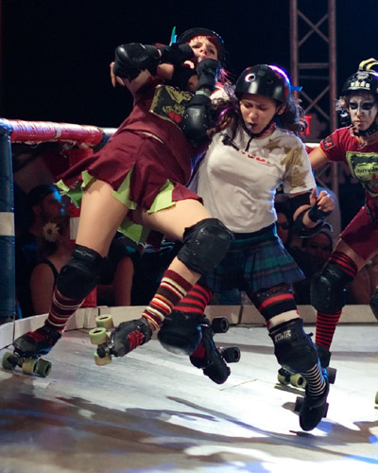
Oct 24, 2004 Holy Rollers vs. Rhinestone Cowgirls (www.txrd.com)

The Rules
The ball is placed at the center of the arena. Two players, one from each team, face off over the ball. The other players spawn in team bases. When the whistle blows, the two central players vie for possession of the ball while their teammates deploy into the arena.
Danger Ball matches are short and vicious—four or five minutes long. When time expires, the team with the most points is victorious. To score, players must carry or throw the ball through goals scattered throughout the arena. The point value of the goals increases linearly—one point for the first goal scored during the match, two points for the second, three for the third and so forth. Players can earn bonus points by carrying the ball through the goal rather than throwing it.
Scoring locations are moving targets. The active goal changes according to a sequential order each time points are scored.
Danger Ball is designed to be a fast-paced game of constantly reversing fortunes: The player carrying the ball suffers a speed penalty, making it very difficult for a team to maintain control of the ball for any length of time. Shifting scoring locations add a strategic element to the frenzy, creating the possibility of big wins for teams that can manage to maintain control of the ball.

Core Mechanic: Speed
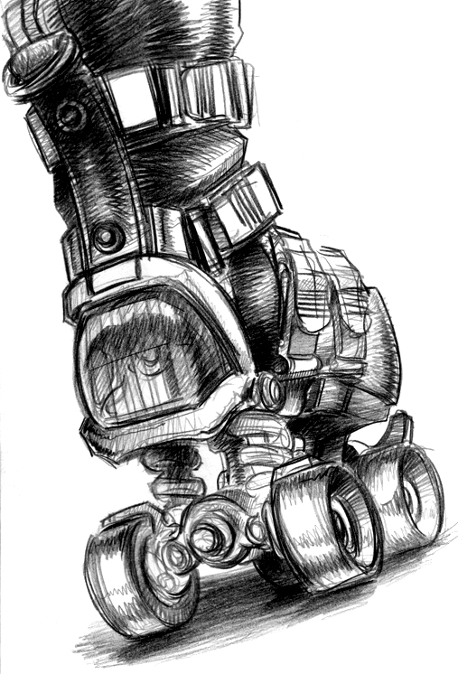
In the Danger Ball arena, it is far easier to speed up than slow down. Speed certainly has its advantages—outrunning the competition, executing outrageous rail grinds, scoring points—but it can also be dangerous: colliding with walls, ramping off high surfaces and wiping out when encountering obstacles such as oil slicks (see Core Mechanic: Weapons, below).
High speeds can increase the damage caused by melee weapons, creating rich possibilities for jousting. Possession of the ball slows players on level or rising surfaces, though on falling surfaces it allows players the additional weight needed to accumulate tremendous speed.
Skate concept art by Kale Menges, 2006
Core Mechanic: Stamina
Stamina is the core metric of Danger Ball, measured in a bar displayed on the HUD. When one player successfully attacks another, the victim loses stamina. A player completely depleted of stamina doesn’t die or respawn. Instead, they lie wounded and in pain for a brief cool down period before they recover stamina and can move again.
Stamina slowly recharges over time, and has other uses as well. A small expenditure of Stamina is required to use a melee or ranged attack. Stamina can also be used as fuel to increase a player’s speed. The faster a Dangerballer skates, the more stamina she will burn. Stamina might also fuel big jumps, half-pipe tricks, or special weapon attacks.
When a player’s stamina has been lowered sufficiently, she hunches over briefly—if she has the ball, she drops it.

Core Mechanic: Weapons
Rather than providing an array of potential implements that are all very similar, Team Ampersand will develop a smaller amount of weapons and make each of them distinctive.
At the beginning of the match, each player chooses a melee weapon—this is the only melee weapon his or her avatar can use until the current match ends.
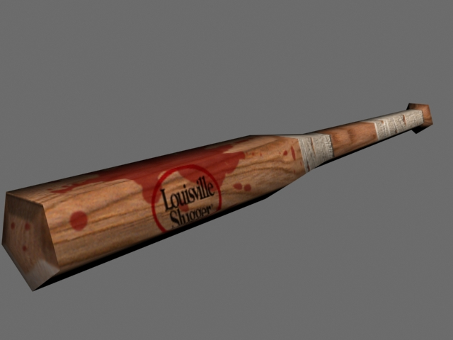
Baton Weapon: For cracking knees and skulls. This weapon might be a baseball bat, hockey stick, lead pipe or a similar implement. Can also be used to block attacks (though less effectively than the shield).

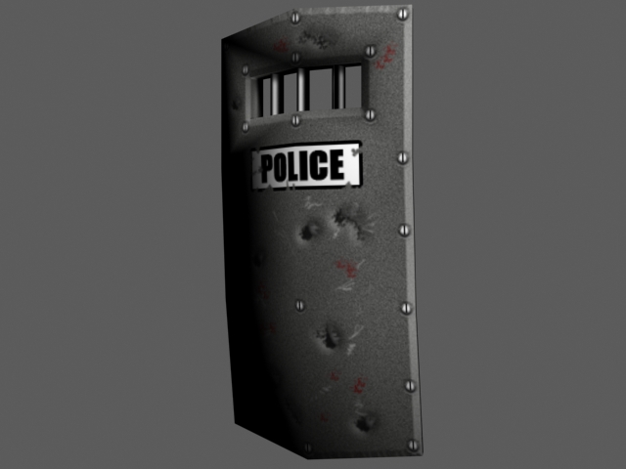
Shield: For ramming opponents at high speeds, and for blocking incoming attacks.

Weapon models by Kale
Menges, 2006

The interface for melee weapons relies on a lock-on targeting system and a “lunge” component—after skating within range of her intended victim, a Danger Ball player can lunge forward, closing the distance and executing a vicious attack.
In addition, grenades are scattered throughout Danger Ball arenas. Only a few can be carried at a time, so Danger Ball contestants must use them sparingly. Grenades come in three varieties:
Freeze Device: A foam or ice attack that reduces an opponent’s speed temporarily.
Oil Slick/Marble Spray: Temporarily renders a portion of the arena dangerous for skaters. Players who skate through affected regions will lose control, often with injurious results.
Explosive: Reduces the stamina of all players within the area of effect.
Grenades are thrown by hand—if a player is carrying the ball, she cannot throw a grenade but throws the ball instead. Because the players in Danger Ball will be in constant motion, ranged weapons will work on an area-of-effect principle rather than pinpoint accuracy.

Core Mechanic: Teamwork
Though Danger Ball is a fast-paced game of bad sportsmanship and reckless skate tricks, it also involves a little sports management. At the start of each match, players choose a weapon and a position (a simple character class). Players must build an effective team from various combinations of starting options and develop strategies that will make the most of a particular starting lineup. A team consisting of heavily armored brutes (i.e., Blockers) encumbered with massive weapons will play very differently from a fast but relatively defenseless team of speed freaks (i.e., Jammers).
Jammers: Score lots of points.
1. Fast acceleration, receives large speed boost for small Stamina expenditures.
2. A Jammer’s melee attacks do very little damage.
3. Fragile: easily injured by melee attacks.
4. Somewhat resistant to the sapping effects of ranged attacks.
5. Suffers only a small speed penalty when carrying the ball.

Blockers: Protect Jammers or set up blocks against opposing Jammers.
1. Slow acceleration, burns more Stamina for less speed than Jammers.
2. Inflicts great damage to opponent’s Stamina when using melee attacks.
3. Resilient: loses less Stamina from melee attacks.
4. More vulnerable to the sapping effects of ranged attacks.
5. Suffers a larger speed penalty when carrying the ball.

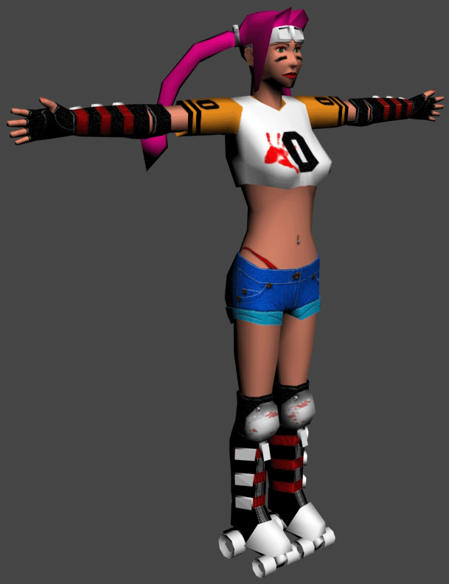
Jammer model by Kale Menges, 2006
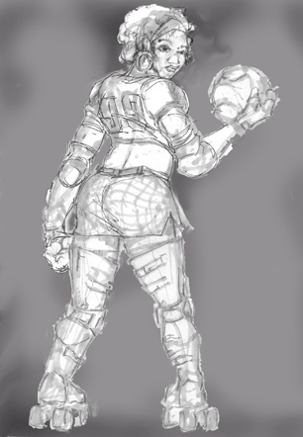
Aesthetics
Danger Ball will rely on a Seventies aesthetic to emphasize the sleazy nature of the sport—pig tails, hot pants, huge lace-up skate boots and so forth. Character and setting assets will be highly stylized rather than photorealistic: Danger Ball is a game of exaggerated—at times cartoonlike—physics,
User Interface
A gaudy retro HUD, reminiscent of a late-70’s pinball machine, overlays the action in the Danger Ball arena. A rotating arrow indicates the direction toward the currently active goal and grows larger as the avatar skates closer. The current score, time remaining in the match and the player’s stamina are also represented on the HUD.
When one skater successfully attacks another, the victim’s HUD will display a comic book onomatopoeia (i.e., BAM!, THWACK!, etc.)

Blocker concept sketch by Jeffrey Cline, 2006
Platform
Danger Ball ’77 will be deployed as a new custom game type for Unreal Tournament 2004. The mod will include three arena-style levels, two sets of custom animations, and assets to represent the depravity of Danger Ball. The camera for the game will be “over-the-shoulder” third person.

